COMPUTER SCIENCE

INVESTIGATORY PROJECT

2020-2021

Mridul Sharma

XII - G

Roll No.

INDEX

1. Certificate
2. Acknowledgement
3. Introduction
4. Workflow
5. List of Functions used in Menu.py file
6. Python Code
7. Outputs

CERTIFICATE

This is to certify that **Mr. Mridul Sharma** of class **XII – G** has prepared the report on the project entitled “Car Selection and Comparison”

This report is the result of his efforts and endeavors. He has successfully completed the above mentioned project in 2019 – 2020. This report is accepted as the final projectfor the subject Computer Science of class XII. He has prepared the report under my guidance.

______________

Mrs. Vineeta Bagga

H.O.D. Computer Science

ACKNOWLEDGMENT

I would like to express a deep token of thanks and gratitude to my project guide **Mrs. Vineeta Bagga** for guiding me immensely through the course of the project. She always evinced keen interest of my work. Her constructive advice and constant motivation has been responsible for the successful completion of this project. I also thank my family and friends for constant support.

_______________

Mridul Sharma

XII – G

Roll no. :

INTRODUCTION

The project “Car Selection and Comparison” aims to help it’s user to find a suitable car and purchase it for themselves. Cars have become an essential part of our lives, they are an irreplaceable mode of transportation, every car is unique to its owner.

Our project aims at providing the user with a list of cars which he/she might considering buying.

In this project, user can select their budget in which they want to buy along with other specifications such as make, model, type, transmission, fuel type.

WORKFLOW

“Car Selection and Comparison” will work in the following way:

1. The user will be given the choice to either use program as an Admin or use it as a user
2. The admin will be given choicesto create table car/features,to insert pre-defined values in table cars/features, to add a new record in table cars/features,to delete a record from table cars/features,to modify a record in table cars/features.
3. The user will be given the choice to display all cars,search and display cars on basis of their make,buy a car by selecting a model, do afull search on custom parametersandcompare features of two cars.

LIST OF FUNCTIONS IN CarSelection&Comparison.py File

|  |  |  |
| --- | --- | --- |
| **S.No** | **Name of the Function** | **Purpose** |
| 1 | create_table_cars | To create table cars |
| 2 | create_table_features | To create table features |
| 3 | insert_values_in_cars | Insert values in table car |
| 4 | insert_values_in_features | Insert values in table features |
| 5 | add_car | Add a record in table cars by taking input from user. |
| 6 | display_cars | Display all records of all cars |
| 7 | modify_cars | Modify a record of table car by taking Car ID as input from user |
| 8 | delete_car | Delete a record from table carby taking model name as input from user |
| 9 | search_car | To display a record by taking Car ID as input from user |
| 10 | add_feature | Add record in table features by taking inputs from user |
| 11 | display_features | Display all record of table features |
| 12 | modify_features | Modify record of table features by taking Car ID as input from user |
| 13 | delete_feature | Delete a record from features by taking Car ID as input from user |
| 14 | search_features | Search a record on basis of Car ID  Which is taken as input from user |
| 15 | select_make | To display records from table cars of aspecific make inputted by user |
| 16 | buy_model | To buy and display a specific car by taking model name as input from user |
| 17 | select_all | Select a record from table cars by taking various parameters as input from user |
| 18 | compare_features | To compare two cars on basis of their features by taking Car ID of both the car as input from user |
| 19 | Main | Is a menu for user interface of program and gives the choice to user to use the program as administrator or as a regular user. |

**CreateTable.py**

**File Name: - CreateTable.py**

**Objective: - This file will create two tables table cars and**

**tablefeatures, for the project named Car Select-Compare.**

CODING

**#To make connection to the database**

**importmysql.connector as ms**

**mycon=ms.connect(host='localhost', user='root', passwd='1234', db='VKDSB')**

**#To create table cars**

**defcreate_table_cars():**

**mycur=mycon.cursor()**

**myquery="""CREATE TABLE cars**

**( carid integer(4) NOT NULL PRIMARY KEY,**

**makevarchar(20) NOT NULL,**

**modelvarchar(20) NOT NULL,**

**typesvarchar(20) NOT NULL,**

**transmissionvarchar(20) NOT NULL,**

**fueltypevarchar(20) NOT NULL,**

**price int(3));"""**

**mycur.execute(myquery)**

**print("Table Created")**

**#To create table features**

**defcreate_table_features():**

**mycur=mycon.cursor()**

**myquery="""CREATE TABLE features**

**( carid integer(4),**

**saftey_ratingvarchar(5) NOT NULL**

**absvarchar(2) NOT NULL,**

**tcvarchar(2) NOT NULL,**

**airbagsint(2) NOT NULL,**

**climate_controlvarchar(2) NOT NULL,**

**anti_theftvarchar(2),**

**foreign key(carid) REFERENCEcars(carid));"""**

**mycur.execute(myquery)**

**print("Table Created")**

**InsertValue.py**

**File Name:- InsertValue.py**

**Objective:- This file will insert values intotable cars and**

**tablefeatures, for the project named Car Select-Compare.**

CODING

**importmysql.connector as ms**

**mycon=ms.connect(host='localhost', user='root', passwd='1234', db='VKDSB')**

**#To insert values into table cars**

**definsert_value_in_cars():**

**mycur=mycon.cursor()**

**query="""INSERT INTO cars VALUES**

**(1,"Maruti","Swift","Hatchback","Manual","Petrol",3),**

**(2,"Honda","Jazz","Hatchback","Automatic","Diesel",5),**

**(3,"Maruti","Ertiga","SUV","Automatic","Petrol",9),**

**(4,"Audi","A4","Sedan","Automatic","Petrol",35),**

**(5,"Honda","Civic","Sedan","Automatic","Diesel",20),**

**(6,"Maruti","Ciaz","Sedan","Manual","Petrol",11),**

**(7,"Hyundai","i10","Hatchback","Manual","Diesel",9),**

**(8,"Huundai","i20","Hatchback","Manual","Diesel",12),**

**(9,"Mahindra","Thar","SUV","Automatic","Petrol",19),**

**(10,"Mahindra","Safari","SUV","Automatic","Diesel",9),**

**(11,"Mahindra","KUV","SUV","Automatic","Electric",21),**

**(12,"Maruti","Alto","Hatchback","Automatic","Petrol",8),**

**(13,"Ford","Ecosport","SUV","Manual","Petrol",7),**

**(14,"Mahindra","Verito","Sedan","AMT","Electric",18),**

**(15,"Hyundai","Creta","SUV","Manual","Diesel",8),**

**(16,"Ford","Endeavour","SUV","Manual","Diesel",35)"""**

**mycur.execute(query)**

**mycon.commit()**

**print("Value Inserted")**

**definsert_value_in_features():**

**mycur=mycon.cursor()**

**query="""INSERT INTO features VALUES**

**(1,"****","Y","N",2,"Y","Y"),**

**(2,"****","Y","Y",4,"Y","Y"),**

**(3,"*****","Y","Y",8,"Y","Y"),**

**(4,"***","Y","Y",6,"N","N"),**

**(5,"****","N","Y",8,"Y","Y"),**

**(6,"**","N","Y",2,"Y","N"),**

**(7,"****","Y","Y",12,"Y","Y"),**

**(8,"*","N","N",2,"N","N"),**

**(9,"****","Y","N",6,"Y","N"),**

**(10,"***","Y","Y",4,"Y","Y"),**

**(11,"****","Y","N",6,"Y","Y"),**

**(12,"**","N","N",4,"Y","N"),**

**(13,"*****","Y","Y",16,"Y","Y"),**

**(14,"***","Y","Y",4,"N","Y"),**

**(15,"****","Y","Y",6,"Y","Y"),**

**(16,"*****","Y","Y",14,"Y","Y");"""**

**mycur.execute(query)**

**mycon.commit()**

**print("Value Inserted")**

**Car.py**

**File Name:- Car.py**

**Objective:- This file will contain fuctions that will help the user to Add, Display ,Modify,Search,Delete entries in table cars.**

CODING

**importmysql.connector as ms**

**mycon=ms.connect(host='localhost', user='root', passwd='1234', db='VKDSB')**

**#To add record in table car**

**defadd_car():**

**mycur=mycon.cursor()**

**carid=int(input("Enter Car Id\t"))**

**make=input("Enter Make\t")**

**model=input("Enter Model name\t")**

**types=input("Enter Type\t")**

**transmission=input("Enter Transmission\t")**

**fueltype=input("Enter Fuel Type\t")**

**price=int(input("Enter Price\t"))**

**query="""Insert into cars(carid,make,model,types,transmission,fueltype,price) VALUES \**

**('%d','%s','%s','%s','%s','%s','%d')""" % (carid,make,model,types,transmission,fueltype,price)**

**mycur.execute(query)**

**mycon.commit()**

**mycur.close()**

**print("Record added\t")**

**#Todislay all records in table cars**

**defdisplay_cars():**

**query="""Select * from cars"""**

**mycur=mycon.cursor()**

**mycur.execute(query)**

**result=mycur.fetchall()**

**for row in result:**

**print("________________________________________ ")**

**print("carid=\t\t\t", row[0] )**

**print("make=\t\t", row[1])**

**print("model= \t\t", row[2])**

**print("types=\t\t\t", row[3])**

**print("transmission= \t\t\t", row[4])**

**print("fueltype= \t\t", row[5])**

**print("price= \t\t", row[6])**

**print("________________________________________")**

**mycon.commit()**

**mycur.close()**

**return**

**#To modify a record in table cars**

**defmodify_cars():**

**mycur=mycon.cursor()**

**carid=int(input("Enter car id you want to modify\t"))**

**make=input("Enter new make \t")**

**model=input("Enter Model Name\t")**

**types=input("Enter Type \t")**

**transmission=input("Enter Transmission \t")**

**fueltype=input("Enter Fuel type \t ")**

**price=int(input("Enter Price \t"))**

**mycur.execute("update cars set make= '%s', model='%s', types='%s',transmission= '%s',\**

**fueltype='%s',price=%d where carid='%d' " \**

**%(make,model,types,transmission,fueltype,price,carid))**

**mycon.commit()**

**mycur.close()**

**print("Record updated\t")**

**return**

**#To delete record from table cars**

**defdelete_car():**

**mycur=mycon.cursor()**

**model=input("Enter Model name you want to delete\t")**

**query="""delete from cars where model=('%s')"""%(model)**

**mycur.execute(query)**

**mycon.commit()**

**mycur.close()**

**print("Record deleted\t")**

**return**

**#To display a record by inputting Car I**

**defsearch_car():**

**w=(input("Enter CAR ID"))**

**mycur=mycon.cursor()**

**query="""select * from cars**

**where carid='%s';"""%(w)**

**mycur.execute(query)**

**res=mycur.fetchall()**

**for row in res:**

**print("________________________________________ ")**

**print("carid=\t\t\t", row[0] )**

**print("make=\t\t\t", row[1])**

**print("model= \t\t\t", row[2])**

**print("types=\t\t\t", row[3])**

**print("transmission= \t\t\t", row[4])**

**print("fueltype= \t\t\t", row[5])**

**print("price= \t\t\t", row[6])**

**print("________________________________________")**

**mycon.commit()**

**mycur.close()**

**Features.py**

**File Name:- Features.py**

**Objective:- This file will help the user to Add, Display,Modify ,Delete, Search records in table features.**

CODING

**importmysql.connector as ms**

**mycon=ms.connect(host='localhost', user='root', passwd='1234', db='VKDSB')**

**#To add a record in table features**

**defadd_feature():**

**mycur=mycon.cursor()**

**carid=int(input(“Enter Car Id\t”))**

**sr=input(“Enter ontro Rating\t”)**

**absd=input(“Enter ABS\t”)**

**tc=input(“Enter TC\t”)**

**airbags=int(input(“Enter no. of Airbags\t”))**

**cc=input(“Enter Climate Control\t”)**

**antitheft=(input(“Enter anti-theft\t”))**

**query=”””Insert into features(carid,ontro_rating,abs,tc,airbags,climate_contol,anti_theft) VALUES \**

**(‘%d’,’%s’,’%s’,’%s’,’%d’,’%s’,’%s’)””” % (carid,sr,absd,tc,airbags,cc,anti_theft)**

**mycur.execute(query)**

**mycon.commit()**

**mycur.close()**

**print(“Record added\t”)**

**#To display all record of table features**

**defdisplay_features():**

**query="""Select * from features"""**

**mycur=mycon.cursor()**

**mycur.execute(query)**

**result=mycur.fetchall()**

**for row in result:**

**print("________________________________________ ")**

**print("carid=\t\t\t", row[0] )**

**print("saftey_rating=\t\t", row[1])**

**print("abs= \t\t", row[2])**

**print("tc=\t\t\t", row[3])**

**print("airbags= \t\t\t", row[4])**

**print("climate_control= \t\t", row[5])**

**print("anti_theft= \t\t", row[6])**

**print("________________________________________")**

**mycon.commit()**

**mycur.close()**

**return**

**#To modify a record in table features**

**defmodify_feature():**

**mycur=mycon.cursor()**

**carid=int(input("Enter car id you want to modify\t"))**

**saftey_rating=input("Enter saftey rating\t")**

**absd=input("Enter abs\t")**

**tc=input("Enter tc \t")**

**airbags=int(input("Enter airbags \t"))**

**climate_control=input("Enter climate control \t ")**

**anti_theft=(input("Enter anti theft\t"))**

**mycur.execute("update features set saftey_rating= '%s', abs='%s', tc='%s',airbags= '%d',\**

**climate_control='%s',anti_theft='%s' where carid='%d' " \**

**%(saftey_rating,absd,tc,airbags,climate_control,anti_theft,carid))**

**mycon.commit()**

**mycur.close()**

**print("Record updated\t")**

**return**

**#To delete a record from table features**

**defdelete_feature():**

**mycur=mycon.cursor()**

**cid=int(input("Enter car id of the record you want to delete\t"))**

**query="""delete from features where carid=('%d')"""%(cid)**

**mycur.execute(query)**

**mycon.commit()**

**mycur.close()**

**print("Record deleted\t")**

**return**

**#To search a record in table features on basis of Car ID**

**defsearch_features():**

**w=(input("Enter CAR ID"))**

**mycur=mycon.cursor()**

**query="""select * from features**

**where carid='%s';"""%(w)**

**mycur.execute(query)**

**res=mycur.fetchall()**

**for row in res:**

**print("________________________________________ ")**

**print("carid=\t\t\t", row[0] )**

**print("saftey_rating=\t\t\t", row[1])**

**print("abs= \t\t\t", row[2])**

**print("tc=\t\t\t", row[3])**

**print("airbags= \t\t\t", row[4])**

**print("climatecontrol= \t\t\t", row[5])**

**print("antitheft= \t\t\t", row[6])**

**print("________________________________________")**

**mycon.commit()**

**mycur.close()**

**UserSelection.py**

**File Name:- UserSelection.py**

**Objective:- This file will help user to search cars with respect to various parameters such as make and do full search to select a car falling in a specified parameters ,It also helps user to buy a car they would like to buy.**

**CODING**

**importmysql.connector as ms**

**mycon=ms.connect(host='localhost', user='root', passwd='1234', db='VKDSB')**

**#To select and display a car on basis of its make**

**defselect_make():**

**print("Select Make of the cars you want to see")**

**w=input("Maruti,Honda,Hyundai,Mahindra,Audi\t")**

**mycur=mycon.cursor()**

**query="""select * from cars**

**where make='%s';"""%(w)**

**mycur.execute(query)**

**res=mycur.fetchall()**

**if not res:**

**print("Our database doesn't have have any cars of the specified manufacturer")**

**else:**

**for row in res:**

**print("________________________________________ ")**

**print("carid=\t\t\t", row[0] )**

**print("make=\t\t", row[1])**

**print("model= \t\t", row[2])**

**print("types=\t\t\t", row[3])**

**print("transmission= \t\t\t", row[4])**

**print("fueltype= \t\t", row[5])**

**print("price= \t\t", row[6])**

**print("________________________________________")**

**mycon.commit()**

**mycur.close()**

**#To display and buy a car by taking input model name**

**defselect_model():**

**print("Select Model")**

**w=(input("Example:Swift,I20...etc\t"))**

**mycur=mycon.cursor()**

**query="""select * from cars**

**where model='%s';"""%(w)**

**mycur.execute(query)**

**res=mycur.fetchall()**

**for row in res:**

**print("________________________________________ ")**

**print("carid=\t\t\t", row[0] )**

**print("make=\t\t\t", row[1])**

**print("model= \t\t\t", row[2])**

**print("types=\t\t\t", row[3])**

**print("transmission= \t\t\t", row[4])**

**print("fueltype= \t\t\t", row[5])**

**print("price= \t\t\t", row[6])**

**print("________________________________________")**

**mycon.commit()**

**mycur.close()**

**#To perform a full search by taking parameters from user**

**defselect_all():**

**print(“Hatchback (5-Seater)/Sedan (5-Seater)/SUV (7-Seater)/MPV (5+2 Seater)”)**

**x=input(“What type of car would you prefer ? “)**

**print(“Automatic(Gear-Less)/Manual(5-Speed)/AMT(5-Speed)”)**

**y=input(“What type of Transmission would you prefer ? “)**

**print(“Petrol/Diesel/Electric”)**

**z=input(“What type of Fuel would you prefer ? “)**

**print(“Select Price Range”)**

**w=int(input(“Enter Lower Limit in Lakhs “))**

**u=int(input(“Enter Upper Limit in Lakhs”))**

**mycur=mycon.cursor()**

**query=”””select * from cars**

**where types=’%s’ and transmission=’%s’ and fueltype=’%s’ and price>’%d’ and price<’%d’;”””%(x,y,z,w,u)**

**mycur.execute(query)**

**res=mycur.fetchall()**

**for row in res:**

**print(“________________________________________ “)**

**print(“carid=\t\t\t”, row[0] )**

**print(“make=\t\t”, row[1])**

**print(“model= \t\t”, row[2])**

**print(“types=\t\t\t”, row[3])**

**print(“transmission= \t\t\t”, row[4])**

**print(“fueltype= \t\t”, row[5])**

**print(“price= \t\t”, row[6])**

**print(“________________________________________”)**

**mycon.commit()**

**mycur.close()**

**COMPARE.py**

**File Name:- COMPARE.py**

**Objective:- This file will help user to compare features of 2 cars by entering Car ID of the cars to compare.**

CODING

**importmysql.connector as ms**

**mycon=ms.connect(host=’localhost’, user=’root’, passwd=’1234’, db=’VKDSB’)**

**defcompare_features():**

**mycur1=mycon.cursor()**

**mycur2=mycon.cursor()**

**c1=int(input(“Enter Car ID of Car 1”))**

**c2=int(input(“Enter Car ID of Car 2”))**

**query=”””select * from features where carid=’%d’”””%(c1)**

**mycur1.execute(query)**

**result=mycur1.fetchall()**

**for row in result:**

**print(“________________________________________ “)**

**print(“carid=\t\t\t”, row[0] )**

**print(“afety_rating=\t\t”, row[1])**

**print(“abs= \t\t”, row[2])**

**print(“tc=\t\t\t”, row[3])**

**print(“airbags= \t\t\t”, row[4])**

**print(“climate_control= \t\t”, row[5])**

**print(“anti_theft= \t\t”, row[6])**

**print(“________________________________________”)**

**mycon.commit()**

**mycur1.close()**

**query=”””select * from features where carid=’%d’”””%(c2)**

**mycur2.execute(query)**

**result=mycur2.fetchall()**

**for row in result:**

**print(“________________________________________ “)**

**print(“carid=\t\t\t”, row[0] )**

**print(“afety_rating=\t\t”, row[1])**

**print(“abs= \t\t”, row[2])**

**print(“tc=\t\t\t”, row[3])**

**print(“airbags= \t\t\t”, row[4])**

**print(“climate_control= \t\t”, row[5])**

**print(“anti_theft= \t\t”, row[6])**

**print(“________________________________________”)**

**mycon.commit()**

**mycur2.close()**

**Menu.py**

**File Name:- Menu.py**

**Objective:-This file is a compilation of all the function created prior. It gives user choice to use various function based on whether the user is an administrator or a normal user.**

**CODING**

**import Car as c**

**importCreateTable as ct**

**importInsertValue as iv**

**importUserSelection as us**

**import Features as f**

**import COMPARE**

**def main():**

**print("1.Admin")**

**print("2.User")**

**sel=int(input("Enter Choice\t"))**

**if sel==1:**

**print("1.Create Table Cars")**

**print("2.Create Table Features")**

**print("3.Insert Values into Cars")**

**print("4.Insert Values into Features")**

**print("5.Add Car")**

**print("6.Delete Car")**

**print("7.Modify Car")**

**print("8.Add Feature")**

**print("9.Delete Feature")**

**print("10.Modify Feature")**

**choice=int(input("Enter Choice\t"))**

**if choice==1:**

**ct.create_table_cars()**

**elif choice==2:**

**ct.create_table_features()**

**elif choice==3:**

**iv.insert_value_in_cars()**

**elif choice==4:**

**iv.insert_value_in_features()**

**elif choice==5:**

**c.add_car()**

**elif choice==6:**

**c.delete_car()**

**elif choice==7:**

**c.modify_cars()**

**elif choice==8:**

**f.add_feature()**

**elif choice==9:**

**f.delete_feature()**

**elif choice==10:**

**f.modify_features()**

**elifsel==2:**

**print("1.Dislpay all cars")**

**print("2.Search on basis of make ")**

**print("3.Search on basis of model")**

**print("4.Full Search custom parameters")**

**print("5.Compare features of 2 cars")**

**print()**

**choiceu=int(input("Enter choice\t"))**

**if choiceu==1:**

**c.display_cars()**

**elifchoiceu==2:**

**us.select_make()**

**elifchoiceu==3:**

**us.select_model()**

**elifchoiceu==4:**

**us.select_all()**

**elifchoiceu==5:**

**COMPARE.compare_features()**

**ans="Y"**

**while ans=="Y":**

**main()**

**ans=input("Enter Y to continue,Enter N to exit\t")**

**OUTPUT**

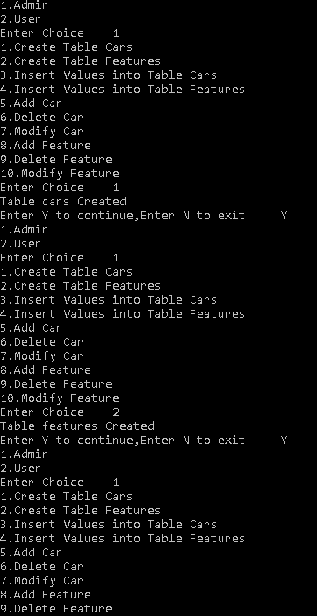

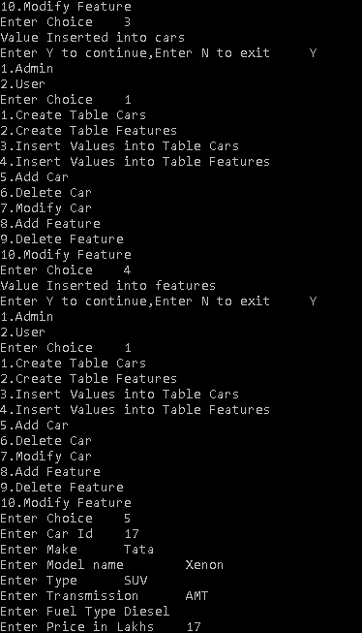

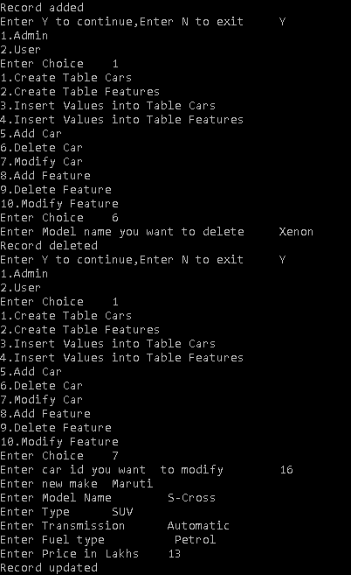

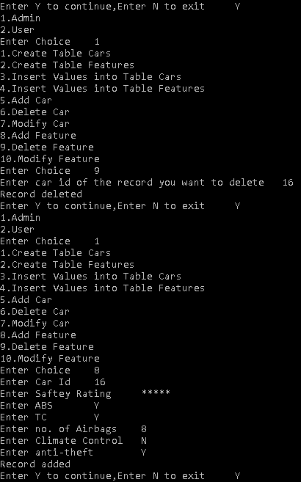

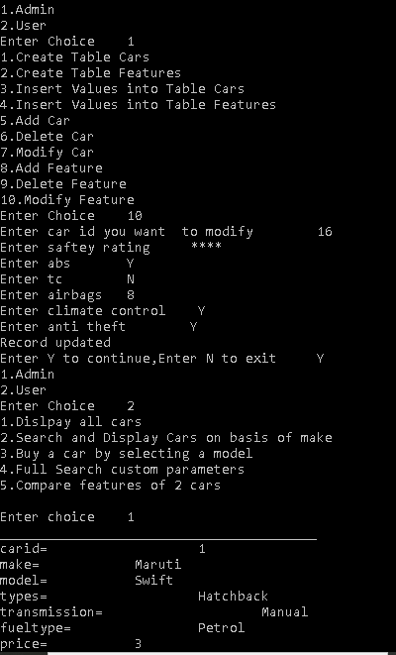

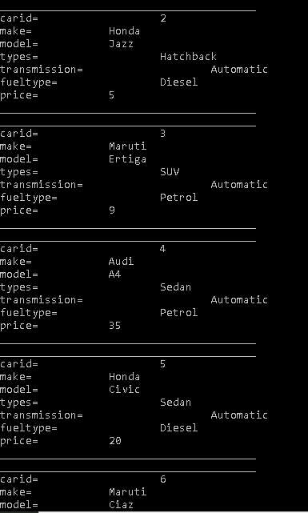

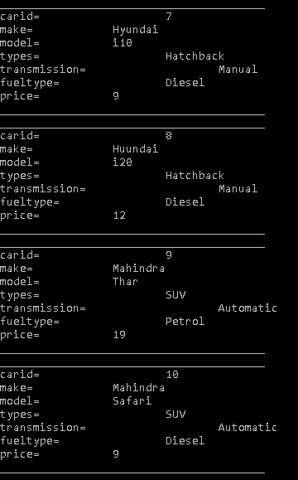

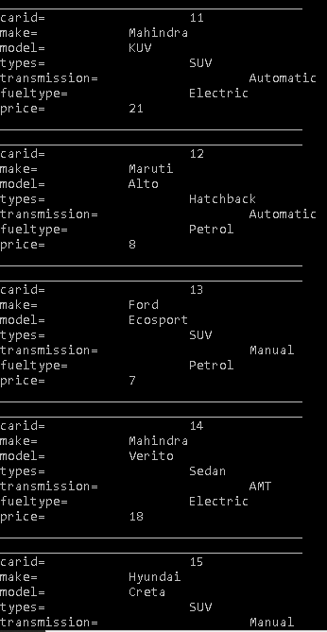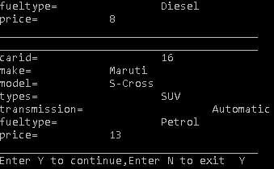

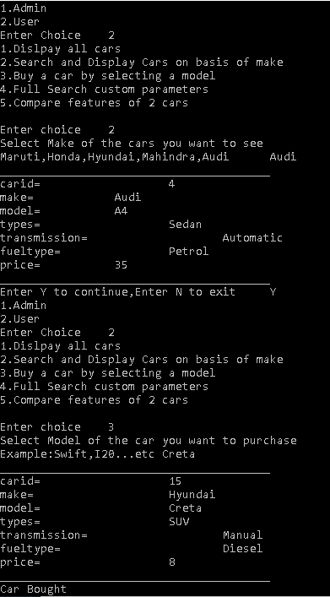

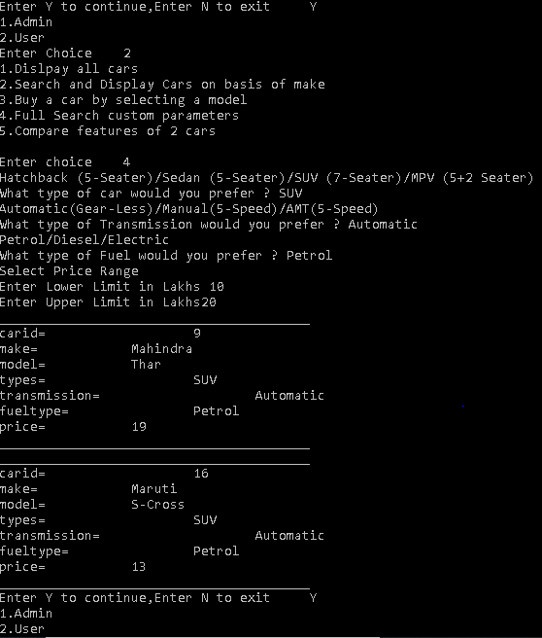

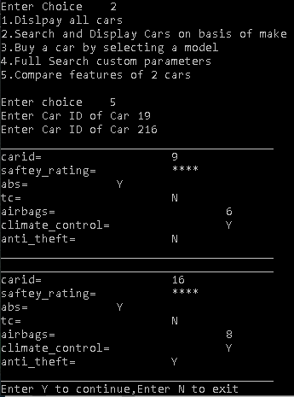

BIBLIOGRAPHY

1. Computer Science with Python
2. www.geekforgeeks.org
3. www.stackoverflow.com
4. www.pythontutor.com